Home page : pic
And pls change color black this words-Industry-Ready Skills

Last pic : Student Success


Our Team :
Name : Jhansi Priya Goud
Senior HR Manager
Linked in: https://www.linkedin.com/in/jhansipriya-guthulla-629000278?utm_source=share&utm_campaign=share_via&utm_content=profile&utm_medium=ios_app
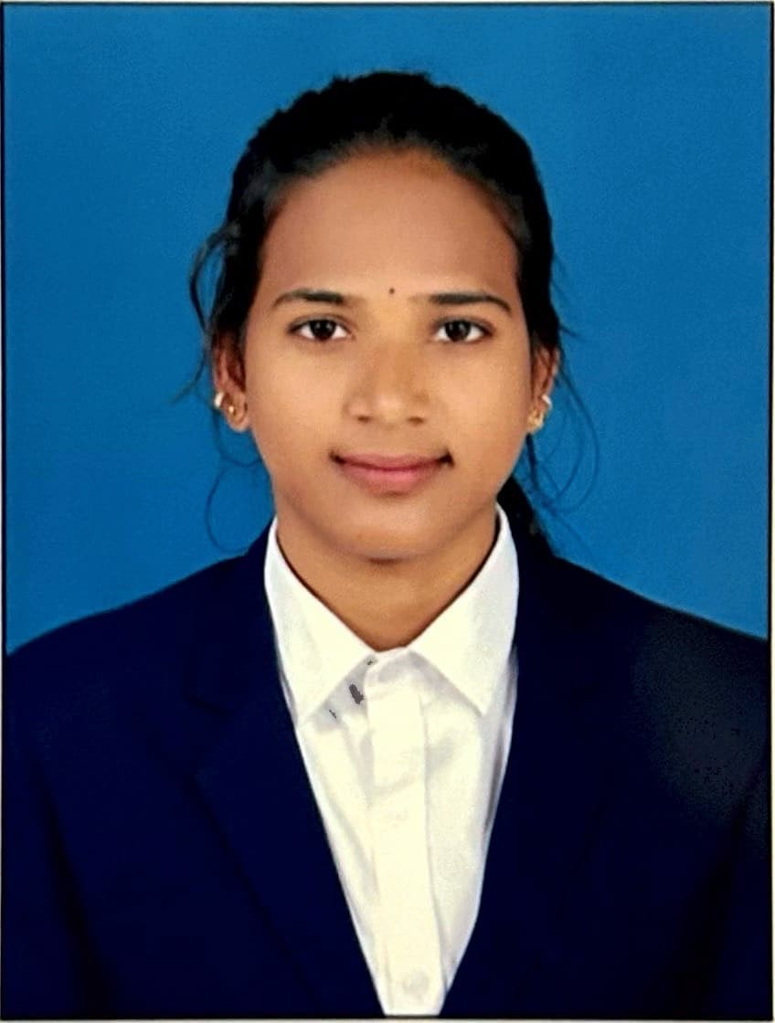

Name: Chandini Attili
HR executive
Linkedin: www.linkedin.com/in/attili-chandini-32409322b


Name: Aparna vushagoni
Senior Manager


Contact us:
Phone number: +91 91120 48888
Linked in for office: https://www.linkedin.com/company/techvid-innovations-pvt-ltd/about/?viewAsMember=true

Google logo:


Current Openings
Team Lead
Senior Manager
Remove UI/UX Design

